|  |
| --- |
| 新东方在线英语学习 |
| 新概念 2 册 |
| Lesson33 |



扫一扫。更多有趣的英语资讯。

1. darkness n. 黑暗

dark adj.

-ness happiness nervousness carelessness

1. explain v. 解释，叙述

explanation n.

1. storm n. 暴风雨

rain storm snow storm sand storm brain storm 头脑风暴

1. towards prep. 向，朝；接近

表示方向感 逐渐接近 接近的过程

towards evening

walk towards the door

The ball flew towards me.

1. ahead adv. 在前面

go ahead

[rock](http://dict.cn/rock.htm)[rɔk] n.岩石，礁石

[light](http://dict.cn/light.htm)[lait] n.灯光

[shore](http://dict.cn/shore.htm) [ʃɔ:] n.海岸

[cliff](http://dict.cn/cliff.htm)[klif] n.峭壁

[struggle](http://dict.cn/struggle.htm)['strʌgl] v.挣扎

[hospital](http://dict.cn/hospital.htm)['hɔspitl] n.医院

# Lesson 33 单词讲解

**Key points:**

**表示地点的介词 (prep.)**

Review:

L9 介词 (prep.)接 名词 代词 动名词

# Lesson 33 课文&语法讲解

1. Nearly a week passed before the girl … explain what had happened to her.

Be able to do 能够做某事

蓝色部分 宾语从句

pass v. A week passed.（主谓结构）

past prep. It is eleven past ten.

n. We cannot change the past.

adj. The past experiences brought me here.

1. … she set out from the coast in a small boat and was caught in a storm. set out / off

be caught in …

I was caught in the traffic jam yesterday.

1. Towards evening, the boat struck rock and the girl jumped into the sea.
2. Then she swam to the shore after spending the … night in the water.

strike struck struck swim swam swum

1. She knew she was near … because the light was high up on the cliff. know knew known

On doing 一怎么怎么样就。。。

1. On arriving at the shore, the girl struggled … towards the light …
2. … the girl struggled up the cliff towards the light she had seen.

蓝色部分 定语从句

the light (that/which) she had seen

定语从句 all是名词 那就是他记得的所有

1. That was all she remembered.
2. all (that) she remembered

表示地点的介词 (prep.) set out from the coast swam to the shore

towards the light she had seen jumped into the sea

out of darkness

表示地点的介词 (prep.) arriving at the shore

at 表示一个地点

on the cliff 表示在上面

in a small boat / in a storm / in hospital 表示在里面

表示地点的介词 (prep.)

* + Don’t throw the rubbish out of the window.
  + Please come into the classroom and join us.
  + He is in Shanghai, and he will fly from Shanghai to Beijing.
  + She hopes that she will stand on the top of the highest mountain some day.
  + 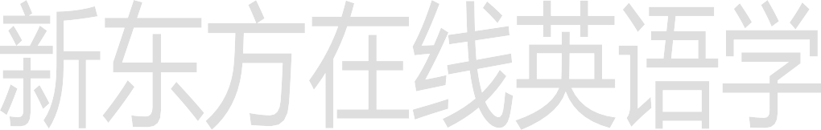It is impolite to point at/to people.
  + I put the laptop into your bag.

# Lesson 33 知识拓展

高考新题型 单词拼写

He tried to (解释), but she wouldn’t listen. explain v.

explanation n. (2010 陕西)

set out to do sth. set off to do sth. set about doing sth. set up + n.

set down + n.

We to paint the whole house but finished only the front part that day.

1. set about
2. set up
3. set out
4. set down (2012 全国 12)

We to paint the whole house but finished only the front part that day.

1. set about
2. set up
3. set out
4. set down

(2012 全国 12)

Armed with the information you have gathered, you can preparing your business plan.

1. set out
2. set about
3. set off
4. set up (2012 浙江 15)

Armed with the information you have gathered, you can preparing your business plan.

1. set out
2. set about
3. set off
4. set up (2012 浙江 15)

* I probably shouldn’t have any more cake.
* Oh, . It won’t kill you.

1. go ahead
2. hold on, please
3. you’re welcome
4. that’ll do



(2011 辽宁 35)

* I probably shouldn’t have any more cake.
* Oh, . It won’t kill you.
  1. go ahead
  2. hold on, please

1. you’re welcome
2. that’ll do (2011 辽宁 35)

阅读理解 介词

* + Some of the best housing London is never advertised but is passed on from one group of students to another by word of mouth.
  + (2010 浙江 阅读B)

阅读理解 介词

* + Neither philosopher lived times of peace, though there were more wars

Greece than China.

* + (2010 江西 阅读 C)

阅读理解 介词

* + Andy rode slowly his way to school, day-dreaming about the fishing trip that his father had promised him.
  + (2010 江西 阅读A)

阅读理解 介词

* + the road to the harbour we could see the terrible destruction the coast, but the harbour itself was in fairly good shape.
  + (2010 湖北 阅读A)

阅读理解 介词

* + Joyce stayed home, cooking and cleaning like a typical housewife of the time, though everything took three times as long.
  + (2010 陕西 阅读 C)

